Fire Alarms:
Indication:
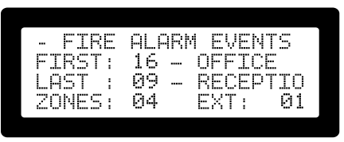
“Fire Alarm Events” will be displayed on the LCD screen.
Active Alarms details will be displayed on the LCD screen.
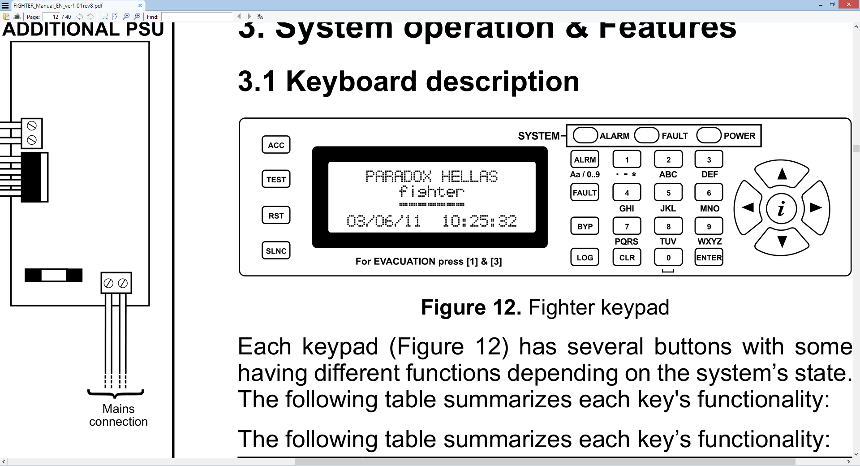
Alarm LED will Flash.
Panel buzzer will sound constantly.
All sounders will activate.

User Action:
Log in with Authorised user code.
Press “SLNC” button.
Do not press “Reset”
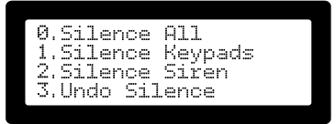

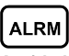
Select Silencing option.
Press “ALRM” button to view Alarm details on the LCD Screen.
If a FIRE is confirmed, press “SLNC” button and select “Undo Silence” to EVACUATE the building occupants.
When confirmation is received that the situation is under control or the building has been completely evacuated from occupants, press “SLNC” button and select “Silence All” to silence the building sounders.
A System Reset can now be performed by pressing the “RST” button.

Fault Condition:
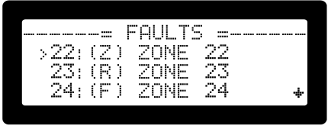
Indication:

“Fire Alarm Events” will be displayed on the LCD screen.
Active Fault details will be displayed on the LCD screen.
Fault LED will Flash.
Panel buzzer will sound constantly
Fault type will be indicated:
- |(Z)|: Zone fault only
- |(R)|: Relay fault only
- |(F)|: Zone and relay faults.
User Action:
Log in with Authorised user code.
Press “SLNC” button.
Do not press “Reset”

Select Silencing option.
Log a call with the Maintenance/Service contractor to inspect, log and rectify the fault.
When the problem has been resolved, a “System Reset” can be performed by the contractor.
Contact Information:
Fire Brigade:
Tel:
Installer:
Name:
Tel:

